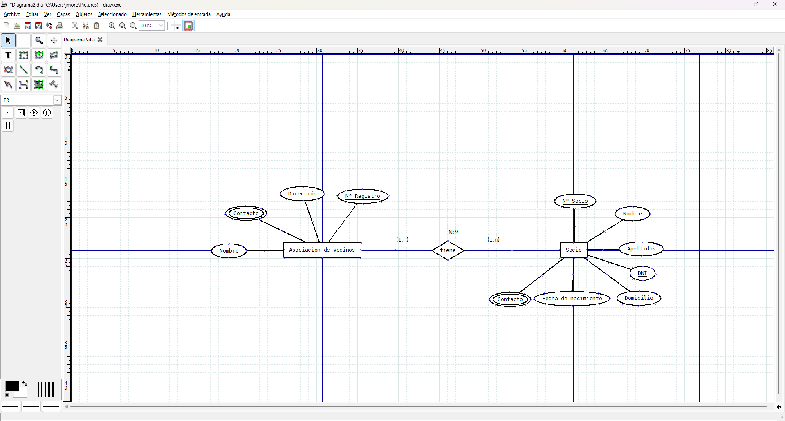
693905757 - cristina bermudez sotysolar

